Payment Wallet

Problem Statement

Objective
Development of an payment wallet application for XYZ bank.

Abstract of the project
This project is aimed at developing an online Payment Wallet Application to do the payments online. This is a web based application that can be accessed over the web. This system can deposit and withdraw the money and can also perform fund transactions. The person can also view the transactions that he has made. This is an integrated system that contains both the user component and the Admin component.

Functional components of the project
Following is a list of functionalities of the system.

- Customer should be able to

  - Create an account.
  - Login to the app using his/her credentials.
  - Deposit the amount.
  - Withdraw the amount.
  - View the balance.
  - Perform fund transfer.
  - Able to print all the transactions.

Design
Layered Architecture
Packages

Bean Package
Com.capgi.paymentwallet.bean
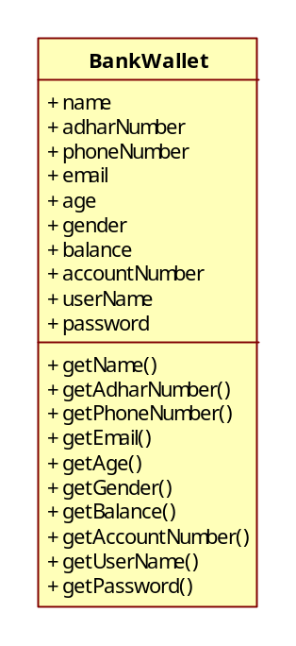

Dao Package
Com.capgi.paymentwallet.dao

Service Package
Com.capgi.paymentwallet.service

UI Package
Com.capgi.paymentwallet.ui

Test Package
Com.capgi.paymentwallet.test

Exception Package
Com.capgi.paymentwallet.exception

Classes

Customer – Bean package
Account – Bean package
ClientWallet – UI Layer
PaymentWalletService – Service Layer
PaymentWalletDao – DAO Layer
PaymentWalletValidate – Service Layer
PaymentWalletException – Exception package
PaymentWalletValidateTest – Test package

Interfaces

IPaymentWalletDao – Dao Layer
IPaymentWalletService – Service Layer

Methods
1.Login()
Parameters-(userName, password)
Return Type - Boolean
1.addCustomerDetails()
Parameters :-bean class object
Return Type :-Boolean
2.deposit()
Parameters:-amount
Return Type:- Boolean
3.withdraw()
Parameters:- amount
Return Type:- Boolean
4.showBalance()
Return Type:- double

5.transferMoney()
Parameters:- (Target account Number, amount)
Return Type: Boolean
6.printTransactions()
Parameters: (transaction_id, amount)
Return Type: Boolean

